Main types of Chemical Reactions

A. Composition or Synthesis Reaction-

Element or compounds react to form JUST ONE PRODUCT.
4 Al + 3O₂ → 2Al₂O₃
N₂O₅ + H₂O → 2HNO₃
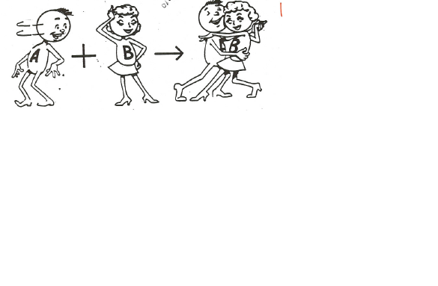

B. Decomposition Reaction-

Start off with JUST ONE REACTANT. It breaks down. Heat, electrolysis, or a catalyst is usually necessary.

2K(ClO₃) → 2KCl + 3O₂
Ca(CO₃) → CaO + CO₂

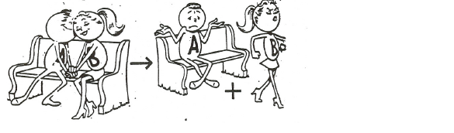

C. Single Replacement Reaction –
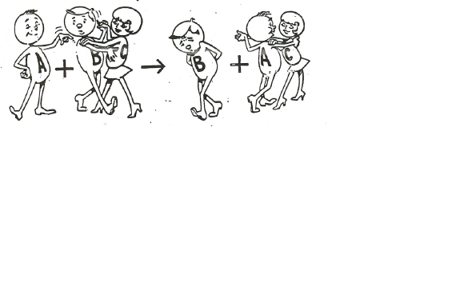

1. A metal bumps a less active metal out of a compound.
Ca + 2Ag(NO₃)(aq) → 2Ag + Ca(NO₃)₂(aq)

2. A nonmetal bumps a less active nonmetal out of a compound.
Cl₂ + 2KI (aq)→ I₂ + 2KCl(aq)

3. Active metals replace less active metals or hydrogen from their compounds in aqueous solution. Use an activity series or a reduction potential table to determine activity. The more easily oxidized metal replaces the less easily oxidized metal. The metal with the most negative reduction potential will be the most active.
Ex. Magnesium turnings are added to a solution of iron(III) chloride.
Mg + Fe³⁺ → Fe + Mg²⁺
Ex. Sodium is added to water.
Na + H₂O → Na⁺ + OH⁻ + H₂

4. Active nonmetals replace less active nonmetals from their compounds in aqueous solution. Each halogen will displace less electronegative (heavier) halogens from their binary salts.

D. Double Replacement-
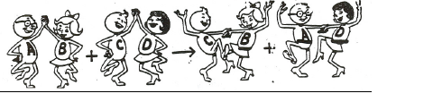

The metals in 2 ionic substances trade places.
Pb(NO₃)₂(aq) + 2KI(aq₎ → PbI₂(s) + 2K(NO₃)(aq)

1. Two compounds react to form two new compounds. No changes in oxidation numbers occur. All double replacement reactions must have a "driving force" that removes a pair of ions from solution.

A. Formation of a precipitate: A precipitate is an insoluble substance formed by the reaction of two aqueous substances. Two ions bond together so strongly that water can not pull them apart. You must know your solubility rules to write these net ionic equations!
Ex. Solutions of silver nitrate and lithium bromide are mixed.
Ag⁺ + Br⁻ → AgBr(s)

B. Formation of a gas: Gases may form directly in a double replacement reaction or can form from the decomposition of a product such as H₂CO₃ or H₂SO₃.
Ex. Excess hydrochloric acid solution is added to a solution of potassium sulfite.
H⁺ + SO₃²⁻ → H₂O + SO₂(g)
Ex. A solution of sodium hydroxide is added to a solution of ammonium chloride.
OH⁻ + NH₄⁺ → NH₃ + H₂O

C. Formation of a molecular substance: When a molecular substance such as water or acetic acid is formed, ions are removed from solution and the reaction "works".
Ex. Dilute solutions of lithium hydroxide and hydrobromic acid are mixed.
OH⁻ + H⁺ → H₂O (HBr, HCl, and HI are strong acids)

E. Combustion Reaction-
2C₂H₆ + 7O₂ → 4CO₂ + 6H₂O
1. Elements or compounds combine with oxygen. Nonmetallic hydrides combine with oxygen to form oxides and water.
Ex. Carbon disulfide vapor is burned in excess oxygen.
CS₂ + O₂ → CO₂ + SO₂
2. Hydrocarbons or alcohols combine with oxygen to form carbon dioxide and water.
Ex. Ethanol is burned completely in air.
C₂H₅OH + O₂ → CO₂ + H₂O

